IT 360 Cloud Integration | Week 2 | Lab (Canvas 2.2)
CI/CD Pipeline from GitHub to an Azure Web App
Click-by-click portal steps with screenshots, the matching terminal commands, and the verification commands for the Canyon Youth Soccer schedule site: a push to main rebuilds and redeploys the site in under a minute
Course: IT 360-01 Cloud Integration, Ensign College
Instructor: Jackson Isiko, Ph.D.
Canvas: 2.2 Team Lab 2, CI/CD Pipeline for React App using GitHub and Azure, 40 points. Time: 60 to 75 minutes.
Companion documents: the README in github-actions-azure-webapp/ (full guide, Vocareum notes, keyless OIDC extension, the Cloud Run twin) and the video in videos/.
Version: 2026-11-01 (command blocks rewritten to paste cleanly into zsh on a Mac and bash in Cloud Shell: values set once as variables in Step 0, no comments or angle brackets inside blocks; verified against a live run on 2026-10-31; second edition of 2026-10-30 added: the Create Web App form filled in and its Review + create page, the App Service plan page retaken, the GitHub New repository form, the local npm start page and the pipeline job's step list were added). Azure portal screenshots were taken from the live portal on 2026-10-29 and 2026-10-30, and every terminal figure is the real output of the instructor run on 2026-10-29. GitHub's pages were captured on 2026-10-30 from the instructor's repository (private, signed in); the GitHub CLI output shows the same runs.

How to use this document
Each step has two parts. The Console box tells you where to click, and the screenshot below it shows the same clicks as red numbered boxes. Above every screenshot a What the next figure shows paragraph explains the page and each mark, so you know what to look for before you see it. Below every command block a table explains each line and what it prints. The Terminal block gives the commands that do the same thing; they are what scripts/deploy-lab2.sh runs. Do a step one way or the other, not both.
Mac users: paste into zsh safely. The Mac Terminal runs zsh, which does not treat # as a comment when you paste, and reads <word> as "take input from the file word". The command blocks in this guide therefore carry no comments and no angle-bracket placeholders: you set your own values once in Step 0 as shell variables, and every later command uses them. If you paste commands from elsewhere that have comments, run setopt interactivecomments once in that Terminal window first. Cloud Shell runs bash and needs neither.
Customize these values to your environment. The Web App name must be unique across all of Azure, so replace jisiko with your team's suffix everywhere. The instructor's subscription has no Free F1 quota in East US, so the run used West US 2; your subscription or the Vocareum sandbox may place F1 in East US. Node 20 LTS was retired in October 2026; pick the newest Node LTS the portal offers (24 LTS at the time of writing).
Item | Value used in this guide | Yours
Resource group | canyon-soccer-rg, West US 2
App Service plan | canyon-asp, Linux, Free F1
Web App | canyon-schedule-jisiko → https://canyon-schedule-jisiko.azurewebsites.net, runtime Node 24 LTS
Repository | isijackson/canyon-schedule, branch main (students: a public repository)
Workflow file | .github/workflows/main_canyon-schedule-jisiko.yml, written by Azure
Live change | one paragraph added to index.js: Field 3 closed for drainage repair on 14 Nov.

Watch out
The pipeline authenticates with a publish-profile secret that Azure writes into the repository. If the Web App is ever deleted and recreated, that secret is stale and every deploy fails with Unauthorized (CODE: 401): reconnect the Deployment Center (or rerun the az webapp deployment github-actions add --force command) to refresh it. This happened in the instructor run and is the first thing to check when a green build does not reach the site.

Step 0. Set your values once per terminal (2 min)
Replace yourteam with your team's suffix (lowercase letters and digits, unique across Azure; the instructor used jisiko), yourgithubuser with your GitHub user name, and the LAB path with the folder where you saved this lab. Run the four lines in every new Terminal or Cloud Shell window before the other blocks.
Terminal on your laptop or Cloud Shell
TEAM=yourteam
GH_USER=yourgithubuser
LAB="$HOME/Downloads/github-actions-azure-webapp"
APP=canyon-schedule-$TEAM
echo "Web App: $APP repository: $GH_USER/canyon-schedule"

Line | What it does and what it prints
TEAM=yourteam | Stores your team's suffix in a shell variable named TEAM. No spaces around =. Nothing is printed.
GH_USER=yourgithubuser | Stores your GitHub user name, used in every repository address.
LAB="$HOME/Downloads/github-actions-azure-webapp" | Stores where the lab folder is on your laptop. The quotes keep paths with spaces intact. Tip: type LAB=", drag the folder from Finder into the Terminal window to paste its path, type the closing ", Enter.
APP=canyon-schedule-$TEAM | Builds the Web App name from your suffix, for example canyon-schedule-jisiko.
echo "Web App: ..." | Prints the values back so you can check them before anything is created.

Expected result
The last line prints your Web App name and repository, for example Web App: canyon-schedule-jisiko repository: isijackson/canyon-schedule.

Part A. Azure resources (15 min)

Step 1. Create the Web App, its plan and its resource group in one form
Console: where to click
Sign in at portal.azure.com, type App Services in the top search box and open it, then click Create → Web App. The Create Web App form opens on its Basics tab (first figure, still showing the defaults).
Project details: Subscription is your subscription. Resource Group (1): click Create new under the dropdown, type canyon-soccer-rg, OK. On a rerun pick the existing group from the dropdown instead, as the second figure shows.
Instance details: Name (2) canyon-schedule-<team>; the portal checks it at once and appends .azurewebsites.net. Publish: Code. Runtime stack (3): open the dropdown and pick Node 24 LTS, the newest LTS listed (Node 20 was retired in October 2026). Operating System: Linux, which the Node stack selects for you.
Region (4): the region where your subscription has Free F1 quota (the instructor's has none in East US, so West US 2). Pricing plans: Linux Plan (5) Create new canyon-asp (on a rerun, pick the existing canyon-asp (F1)); Pricing plan Free F1 (1 GB memory). Leave Zone redundancy disabled.
Click Review + create (6) at the bottom. The Review + create tab (fourth figure) lists every value; read it once, then click Create. The portal creates the resource group, the plan and the app together in about a minute and shows Go to resource when it is done.

What the next figure shows: The Basics tab of the Create Web App form as it opens, before anything is typed: every dropdown shows its default and the Linux Plan dropdown is greyed out until a region is chosen. The red numbers in this first figure are the portal's own section numbers, not the lab's; the next two figures show the same form filled in with the lab's numbering.
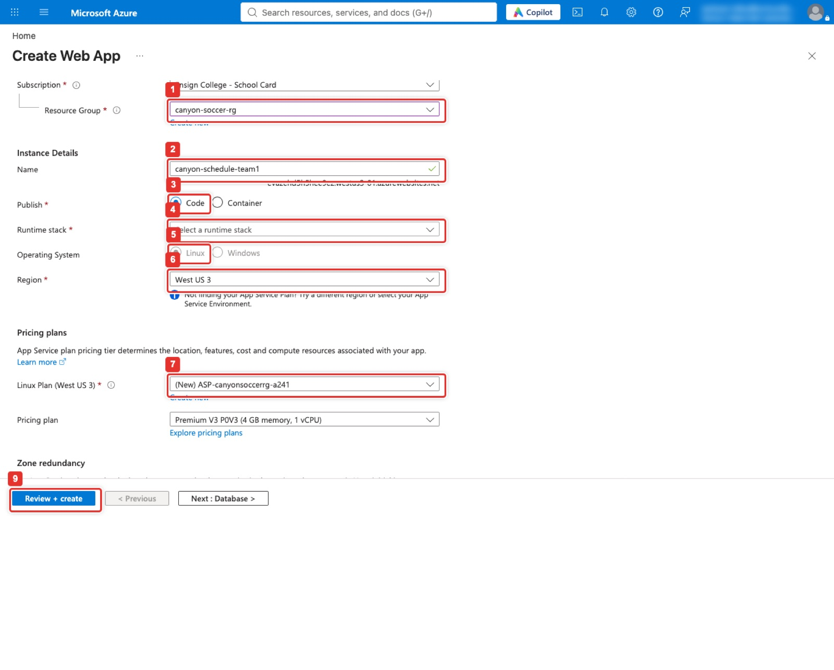
Figure 1. Create Web App, Basics: resource group, name, Code, runtime stack, Linux, region, plan, Review + create.
What the next figure shows: The top half of the Basics tab after the values are entered. Resource Group (1) shows canyon-soccer-rg chosen from the dropdown (on a first run you click Create new under it and type the name). Name (2) holds canyon-schedule-jisiko; the red not available in West US 2 message appears only because the instructor's app of that name already exists, and you will not see it with your own suffix. Publish is Code, Runtime stack (3) is Node 24 LTS, and Operating System switched itself to Linux when the stack was picked.
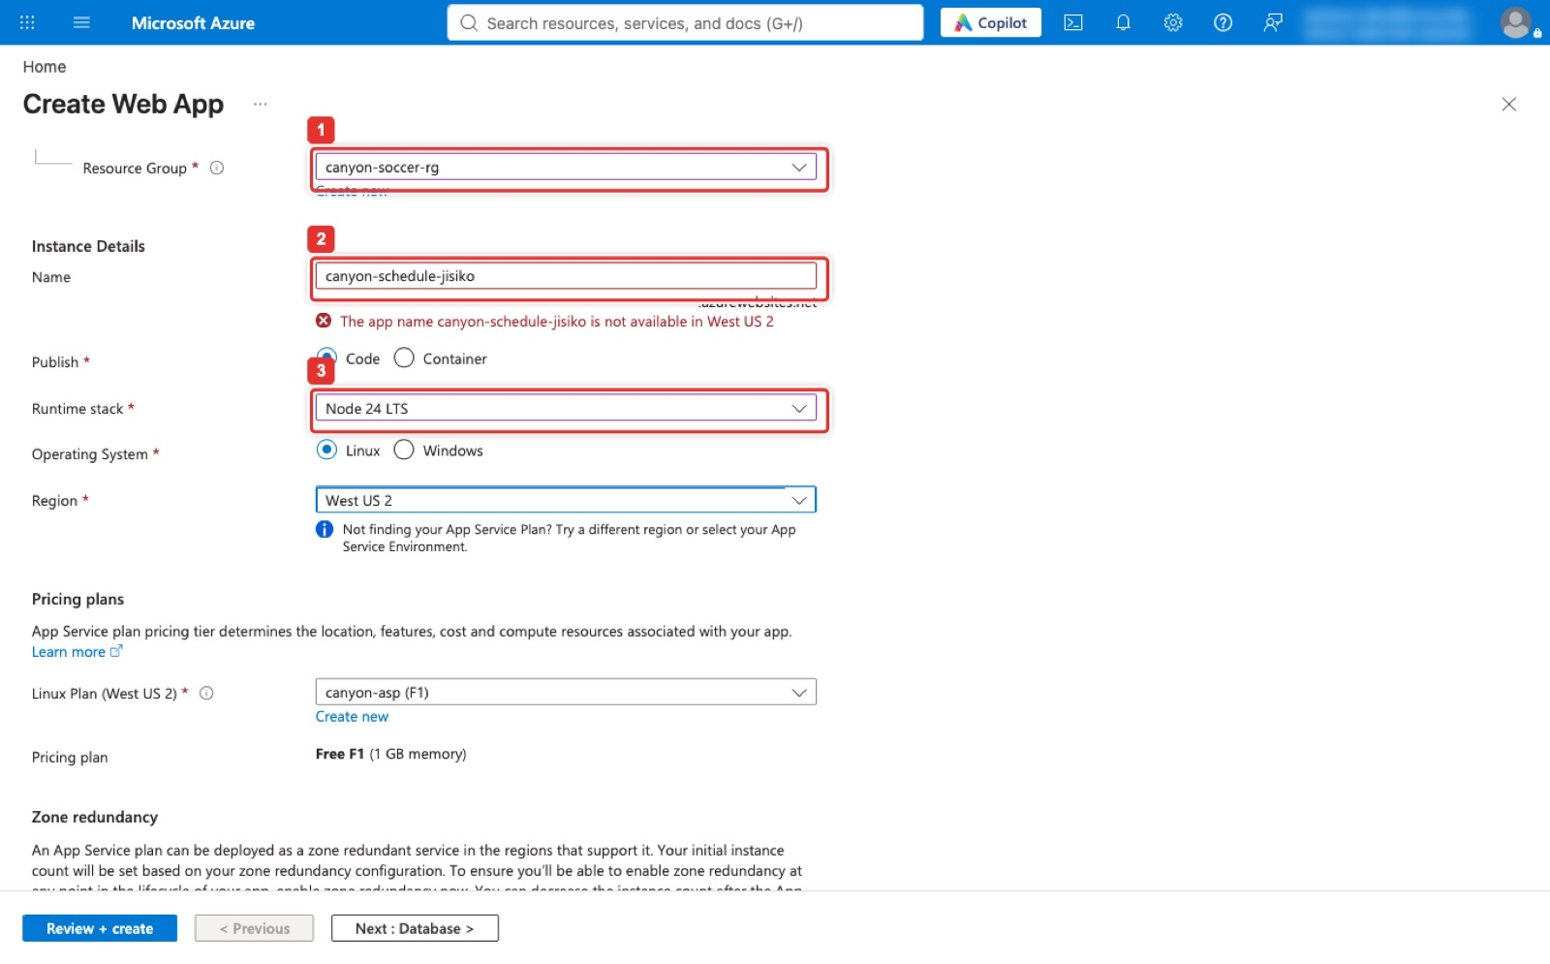
Figure 2. Basics filled in: existing resource group, the app name, Code, Node 24 LTS, Linux.
What the next figure shows: The lower half of the same form. Region (4) is West US 2; the moment it was chosen the Linux Plan dropdown (5) became active and offered the existing canyon-asp (F1) (on a first run click Create new under it, type canyon-asp, and pick Free F1 in the pricing dialog). The Pricing plan line reads Free F1 (1 GB memory), and Zone redundancy below it stays disabled, which F1 requires. Review + create (6) is the blue button in the bar at the bottom; Next: Database and the other tabs can be skipped.
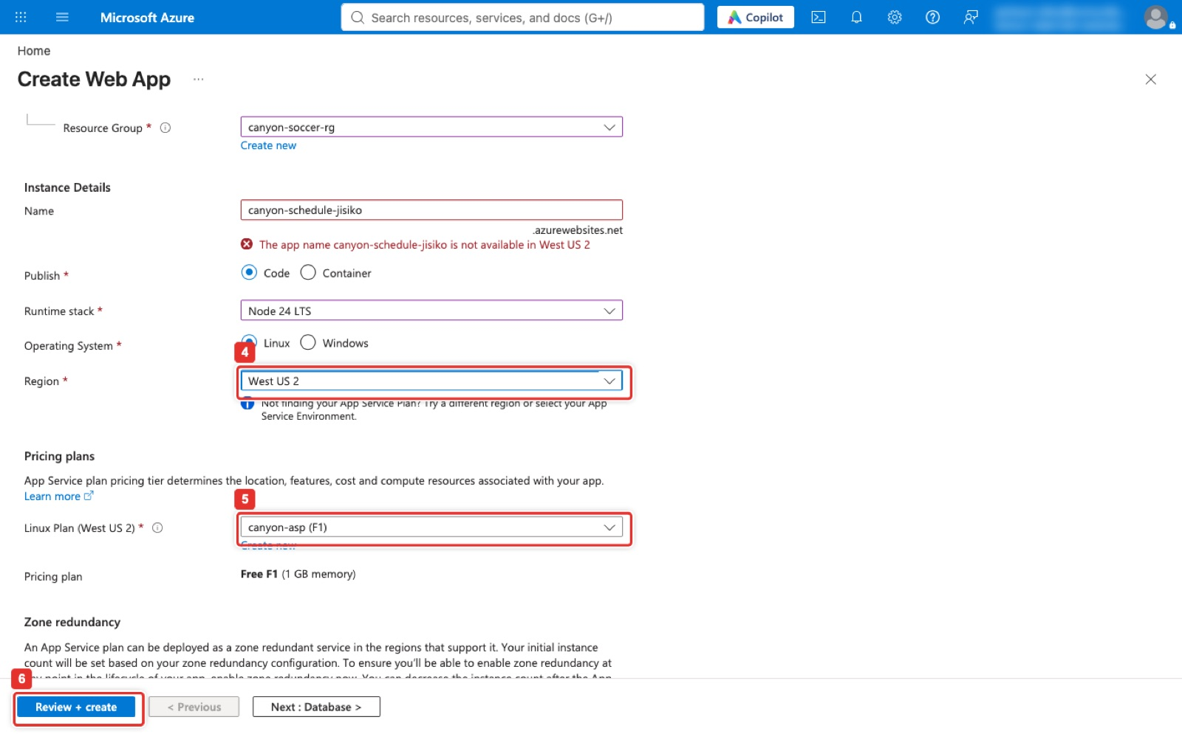
Figure 3. Region, the Linux plan and Review + create.
What the next figure shows: The Review + create tab. The Summary lists the subscription, the resource group, the name, Secure unique default hostname Enabled, Publish Code and Runtime stack Node 24 LTS, then the App Service Plan block with canyon-asp, Linux, West US 2, SKU Free and 1 GB memory. Create (1) at the bottom is greyed out in this figure because the instructor's form failed validation on the name that already existed (the red banner at the top says so); with a free name the button is blue and one click builds all three resources. Previous (2) returns to Basics to fix anything the banner complains about.
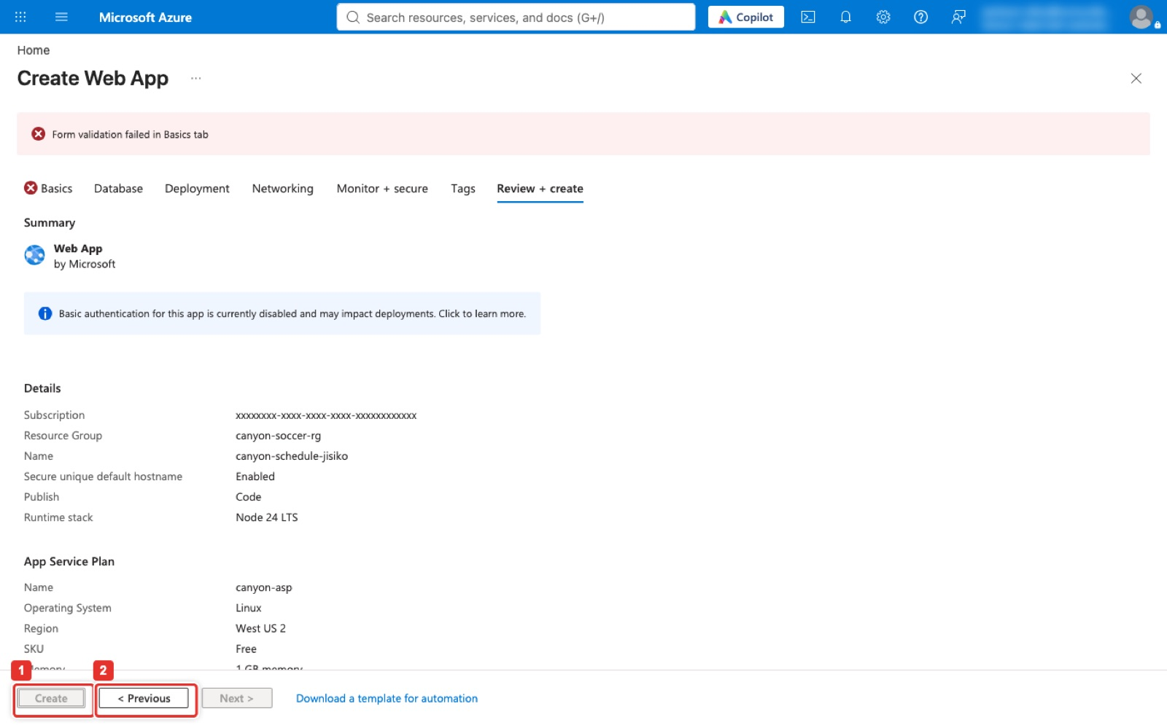
Figure 4. Review + create: every value on one page, then Create.
What the next figure shows: The canyon-soccer-rg resource group with its two resources: the App Service plan canyon-asp (1) and the Web App canyon-schedule-jisiko (2), both in West US 2. Deleting this group in Part F removes both. Click either name to open it.
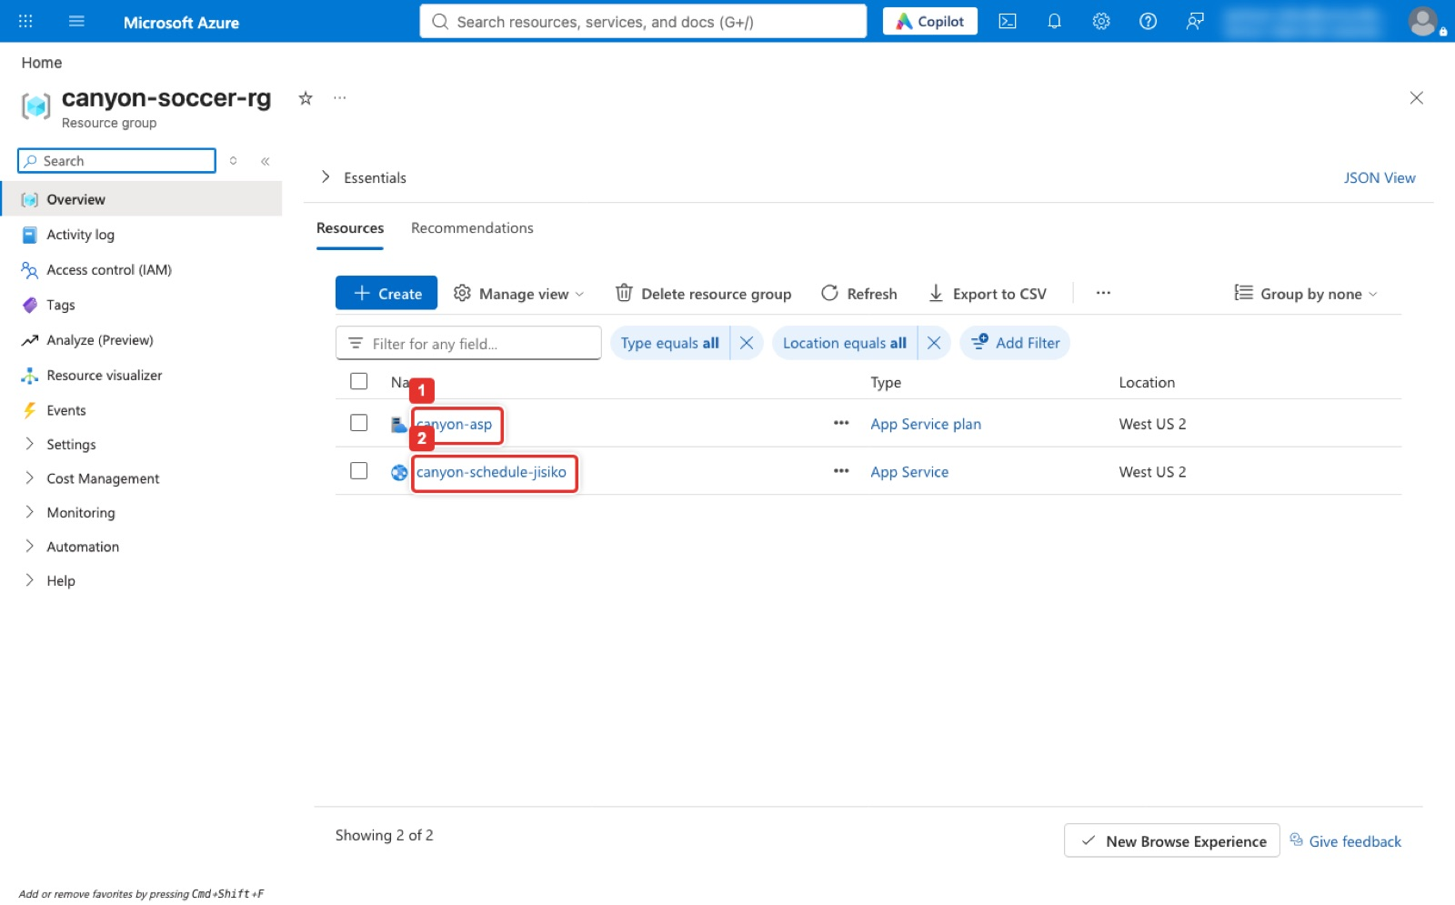
Figure 5. The resource group after creation: the plan and the Web App.
What the next figure shows: The plan's overview page, reached by clicking canyon-asp in the resource group; the header calls it a Linux plan. The Essentials panel shows the resource group canyon-soccer-rg, Status Ready, Location West US 2, the subscription (its ID is blurred here), and on the right Pricing plan F1, Instance count 1, App(s) / Slots 1 / 0, Operating System Linux and Zone redundant Disabled. The blue banner says plan metrics are not applicable to the Free SKU, which is why the CPU, Memory and Data In charts underneath stay empty. F1 is free, so forgetting to delete it costs nothing, but it is limited to 60 CPU minutes a day and has no custom domains or slots; Scale up under Settings in the left menu is where a paid tier would be chosen.
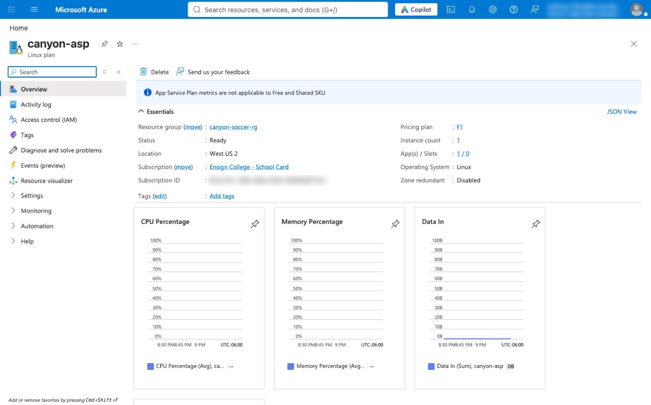
Figure 6. The App Service plan: Linux, Free F1, West US 2, one app.
Terminal on your laptop with `az login` (or Cloud Shell in the Vocareum portal)
az group create -n canyon-soccer-rg -l westus2
az appservice plan create -g canyon-soccer-rg -n canyon-asp -l westus2 --is-linux --sku F1
az webapp list-runtimes --os-type linux | grep -i node
az webapp create -g canyon-soccer-rg -p canyon-asp -n "$APP" --runtime "NODE:24-lts"
az webapp config appsettings set -g canyon-soccer-rg -n "$APP" --settings SCM_DO_BUILD_DURING_DEPLOYMENT=true

Line | What it does and what it prints
az group create -n canyon-soccer-rg -l westus2 | Creates the resource group, the folder that holds everything for this lab, in West US 2. Prints JSON ending in "provisioningState": "Succeeded".
az appservice plan create ... --is-linux --sku F1 | Creates the App Service plan, the server capacity the app runs on: Linux, Free tier F1. The JSON shows "name": "F1" and "tier": "Free".
az webapp list-runtimes --os-type linux | grep -i node | Lists the language versions App Service supports and keeps only the Node lines (| passes the list to grep, -i ignores upper and lower case). On 2026-11-01: NODE:26, NODE:24-lts, NODE:22-lts.
az webapp create ... -n "$APP" --runtime "NODE:24-lts" | Creates the Web App on that plan with Node 24. The JSON includes "defaultHostName": "canyon-schedule-<suffix>.azurewebsites.net", the live address.
az webapp config appsettings set ... SCM_DO_BUILD_DURING_DEPLOYMENT=true | Tells Azure to run npm install itself whenever new code arrives. Prints the app's settings as JSON, including this one with value true.

The list-runtimes line prints the Node versions App Service offers; on 2026-11-01 it listed NODE:26, NODE:24-lts and NODE:22-lts. Use the newest one marked -lts in the --runtime value. If you already ran the first two lines, run them again or skip them: creating a group or plan that exists changes nothing.
What the next figure shows: Part 1 of deploy-lab2.sh. The script picks the newest Node LTS the platform offers (NODE:24-lts), creates the group, the plan and the app, and the last line is Validation 1: a curl of the new site returns HTTP 200, which at that moment is Azure's default welcome page.
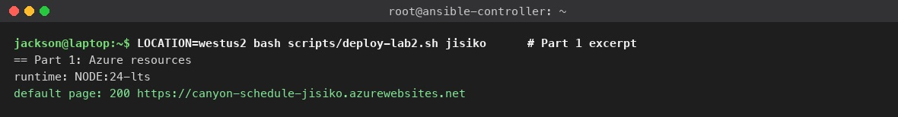
Figure 7. The scripted Part 1: runtime chosen, Web App created, default page answers 200.
What the next figure shows: The Web App's overview page. The Default domain (1) in the Essentials panel is the live URL, canyon-schedule-jisiko.azurewebsites.net; Browse (2) in the toolbar opens it. Deployment Center is in the left menu under Deployment, below the visible part of the list in this figure. Status Running and the plan name are also shown.
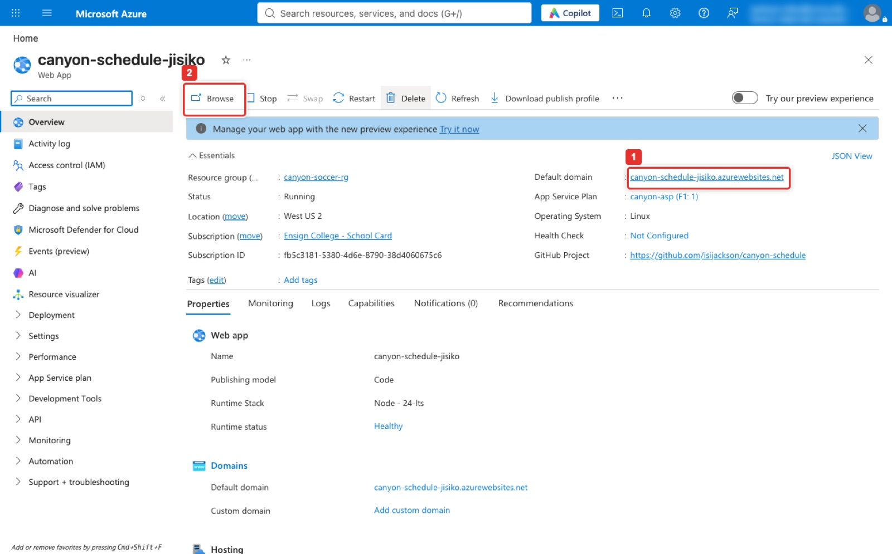
Figure 8. The Web App overview: the default domain, Browse, and Deployment Center in the left menu.
Expected result
Browse shows the Azure default page (Screenshot 1). That is Validation 1.

Part B. The repository and the app (30 min)
Part B has four steps: sign in to Git and GitHub on your laptop (once per laptop), create the empty repository on GitHub, put the app's three files in a local copy of that repository and run them, then push the files to GitHub. Three tools take part. git keeps the history of your files on your laptop. GitHub is the website that holds the shared copy, which Azure will deploy from. gh, the GitHub CLI, is an optional helper that signs you in and can create repositories from the Terminal.

Step 2a. Sign in to Git and GitHub (once per laptop, 10 min)
First check that the tools are installed. Each line prints a version number.
Terminal on your laptop
git --version
node --version
npm --version
gh --version

Line | What it does and what it prints
git --version | Prints the Git version, for example git version 2.54.0 (Apple Git-157). On a Mac without Git, macOS offers to install the Command Line Developer Tools; accept, or run xcode-select --install.
node --version | Prints the Node.js version, for example v24.7.0. The app needs Node 22 or newer; install the LTS version from nodejs.org if it is missing.
npm --version | npm is Node's package installer and comes with Node, for example 11.5.1.
gh --version | Prints the GitHub CLI version, for example gh version 2.67.0. It is optional: install it from cli.github.com (or brew install gh), or skip it and use a token as described below.

Next tell Git who you are. Git writes this name and e-mail into every commit, and GitHub uses the e-mail to link commits to your account, so use the e-mail of your GitHub account.
Terminal on your laptop
git config --global user.name "Your Name"
git config --global user.email "you@example.com"
git config --global init.defaultBranch main
git config --global --list

Line | What it does and what it prints
git config --global user.name "Your Name" | Sets the author name for commits on this laptop. --global means for every repository of your user account, so you do it once.
git config --global user.email "you@example.com" | Sets the author e-mail. Use the address of your GitHub account.
git config --global init.defaultBranch main | New repositories start on a branch called main, the name GitHub and the Azure pipeline use.
git config --global --list | Shows what is set. Expect user.name=..., user.email=... and init.defaultbranch=main.

Then sign in to GitHub from the Terminal. GitHub stopped accepting your account password for git push in 2021, so Git needs either the GitHub CLI's sign-in or a personal access token. The CLI route is easier:
Terminal on your laptop
gh auth login

Line | What it does and what it prints
? Where do you use GitHub? | Press Enter on GitHub.com.
? What is your preferred protocol for Git operations on this host? | Press Enter on HTTPS.
? Authenticate Git with your GitHub credentials? | If this question appears, answer Y. (On a Mac where Git already uses the keychain it may be skipped; the setup-git line below covers that case.)
? How would you like to authenticate GitHub CLI? | Press Enter on Login with a web browser.
! First copy your one-time code: XXXX-XXXX | Copy the eight-character code, press Enter, and the browser opens github.com/login/device. Sign in to GitHub if asked, paste the code, click Continue, then Authorize github. The Terminal prints Logged in as and your user name.

Terminal on your laptop
gh auth setup-git
gh auth status

Line | What it does and what it prints
gh auth setup-git | Tells Git to borrow the GitHub CLI's sign-in whenever it talks to github.com, so git clone and git push never ask for a password.
gh auth status | Checks the sign-in. Expect Logged in to github.com account <your user> and Git operations protocol: https.

Note
Without the GitHub CLI. On github.com open your picture (top right) → Settings → Developer settings → Personal access tokens → Tokens (classic) → Generate new token (classic). Note IT 360 laptop, expiration 30 days, tick the repo and workflow scopes, Generate token, and copy the token (it is shown once). The first time git clone or git push asks for Username, type your GitHub user name; for Password, paste the token, not your account password. On a Mac the keychain remembers it, so you are asked only once.

Step 2b. Create the empty repository on GitHub (5 min)
Console: where to click
On github.com click the + at the top right → New repository (or open github.com/new). Repository name (1) canyon-schedule; leave Description empty; visibility (2) Public, which the Canvas guide requires; leave Add README, .gitignore and license off, because the app files come from this lab. Click Create repository (3).
GitHub opens the new repository's Quick setup page. It shows the repository's address, https://github.com/<your user>/canyon-schedule.git, and two sets of commands. You do not need to type them: Step 2c below does the same job with the lab's files, and the table after Step 2d explains what GitHub's lines mean.

What the next figure shows: GitHub's New repository form. Owner is your GitHub user and Repository name (1) holds canyon-schedule; the red already exists in this account line under it shows only because the instructor's repository exists, and you will see a green tick instead. Public (2) is the visibility; Add README, .gitignore and license stay off. Create repository (3) at the bottom makes the empty repository and opens its quick-setup page with the git remote add origin and git push -u origin main lines ready to copy.
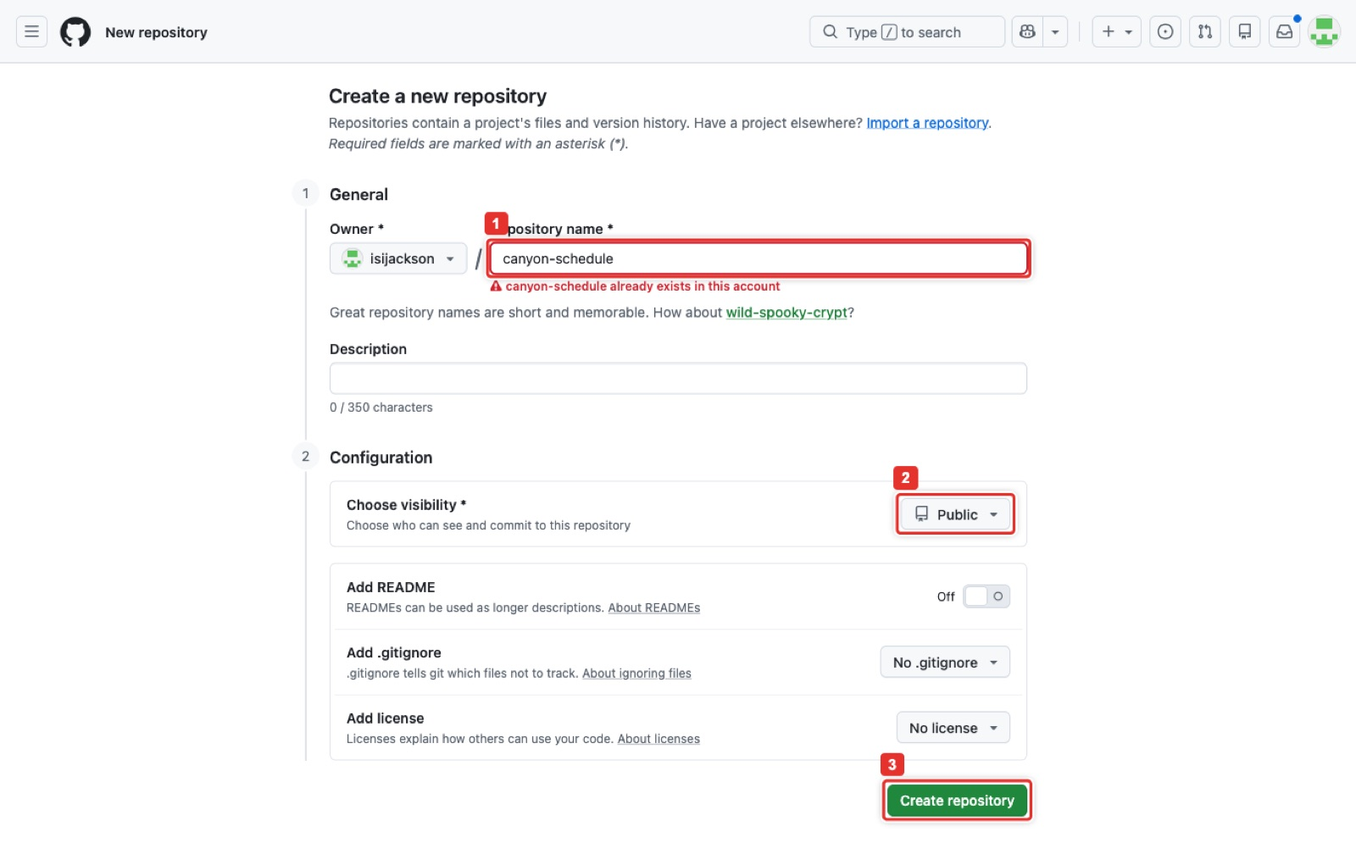
Figure 9. GitHub: Create a new repository with the name, Public, and Create repository.

Step 2c. Get the app's three files
The app is three small files in the canyon-schedule/ folder of this lab: package.json, index.js and .gitignore. Step 0 set LAB to the lab folder on your laptop, so $LAB/canyon-schedule is where they are. If you do not have the lab folder, create the three files by hand: make an empty folder, open it in the Terminal, and paste each block below. Each block writes one file; the line EOF ends the file.
package.json: the app's name, its start and test commands, and its one dependency (Express)
cat > package.json <<'EOF'
{
"name": "canyon-schedule",
"version": "1.0.0",
"main": "index.js",
"scripts": { "start": "node index.js", "test": "node -e \"require('./index.js'); setTimeout(()=>process.exit(0),500)\"" },
"dependencies": { "express": "^4.21.2" }
}
EOF

index.js: a web server that answers every visit to / with the schedule page
cat > index.js <<'EOF'
const express = require('express');
const app = express();
app.get('/', (req, res) => res.send('<h1>Canyon Youth Soccer — Fall Schedule</h1><p>Saturday games at Flat Iron Mesa Park, 9:00 and 10:30.</p>'));
app.listen(process.env.PORT || 3000, () => console.log('Schedule site running'));
EOF

.gitignore: tells Git not to upload the downloaded packages
cat > .gitignore <<'EOF'
node_modules
EOF

Line | What it does and what it prints
"start": "node index.js" | npm start runs the app. Azure runs the same command when it starts the site.
"test": ... | npm test loads the app for half a second and exits. The pipeline runs it, so a file with a syntax error fails the build instead of reaching the live site.
app.get('/', ...) | When a browser asks for the home page, send back the heading and the schedule line.
process.env.PORT || 3000 | Listen on the port Azure provides in PORT; on your laptop, where PORT is not set, use 3000.
node_modules in .gitignore | npm install downloads about 68 packages into node_modules. They are rebuilt from package.json everywhere, so they stay out of the repository.

Step 2d. Clone, copy the files in, run the app, push (10 min)
Run these blocks one after another in the same Terminal window where you ran Step 0. Below each block, the table says what every line does and what it prints.
Terminal on your laptop: make a local copy of the empty repository
cd ~
git clone "https://github.com/$GH_USER/canyon-schedule.git"
cd canyon-schedule
git status

Line | What it does and what it prints
cd ~ | Go to your home folder, so the repository folder is created there.
git clone "https://github.com/$GH_USER/canyon-schedule.git" | Download the repository into a new folder canyon-schedule and remember GitHub as origin. It prints Cloning into 'canyon-schedule'... and warning: You appear to have cloned an empty repository., which is expected: the repository has no files yet.
cd canyon-schedule | Move into the new folder. Every later command runs here.
git status | Prints On branch main, No commits yet and nothing to commit.

Terminal on your laptop: copy the app in and run it
cp -r "$LAB/canyon-schedule/." .
ls -a
npm install
npm start

Line | What it does and what it prints
cp -r "$LAB/canyon-schedule/." . | Copy everything in the lab's canyon-schedule folder into this one (. means "here"). The /. at the end makes the copy include the hidden .gitignore. If you wrote the files by hand in Step 2c, copy them here instead, or create them here directly.
ls -a | Lists the folder, hidden files included. Expect .git, .gitignore, index.js and package.json.
npm install | Reads package.json and downloads Express and the packages it needs into node_modules. It prints added 68 packages ... in 2s and found 0 vulnerabilities. It also writes package-lock.json, which records the exact versions; that file is committed.
npm start | Starts the app. It prints > node index.js and Schedule site running, and keeps running: the Terminal does not return to the prompt while the site is up.

Open http://localhost:3000 in a browser while npm start runs. The page below is Screenshot 2. Then click back in the Terminal and press Ctrl+C to stop the app; the prompt returns.
What the next figure shows: What the browser shows at http://localhost:3000 while npm start runs: the heading Canyon Youth Soccer, Fall Schedule and one line about the Saturday games at Flat Iron Mesa Park. This is Screenshot 2 for Canvas (include the address bar in yours). index.js is twelve lines of Express serving this page on the port in the PORT environment variable, 3000 by default, which is also what App Service sets when it runs the app.

Figure 10. The app running on your laptop: http://localhost:3000 after npm start.
Terminal on your laptop: record the files and send them to GitHub
git add .
git status
git commit -m "Initial schedule site"
git push origin main

Line | What it does and what it prints
git add . | Marks every new or changed file in this folder for the next commit, except what .gitignore excludes.
git status | Shows what will be committed: new file: .gitignore, index.js, package-lock.json, package.json. node_modules must not be in the list; if it is, .gitignore is missing.
git commit -m "Initial schedule site" | Saves the marked files as one snapshot with that message, on your laptop only. It prints [main (root-commit) ...] Initial schedule site and 4 files changed.
git push origin main | Uploads the main branch to origin (GitHub). It ends with To https://github.com/<your user>/canyon-schedule.git and * [new branch] main -> main. Reload the repository page on GitHub: the four files are there.

What the next figure shows: Part 2 of the script. Because the instructor's repository already existed, the script cloned it and pushed the lab folder's version of the app; on a first run it creates the repository with gh repo create. npm test starts the app for half a second to prove index.js loads, and the repo URL is printed. On your laptop, npm start and a browser at port 3000 is Screenshot 2.
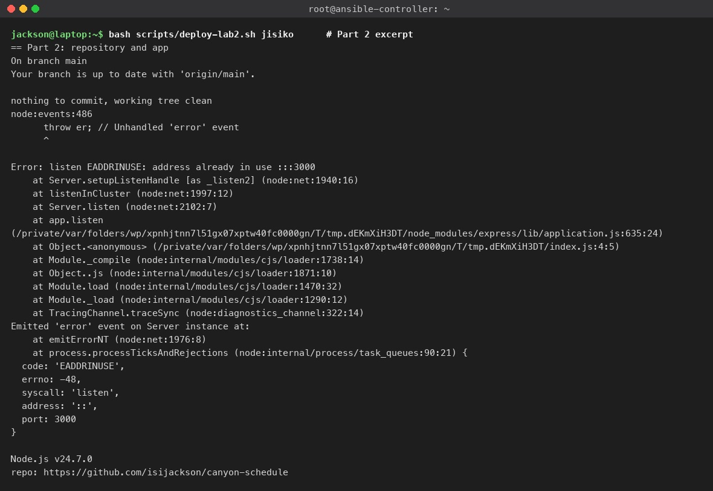
Figure 11. The scripted Part 2: the repository synced, the app passes npm test, the repo URL.
What the next figure shows: github.com/isijackson/canyon-schedule after the pushes. The file list holds index.js, package.json, package-lock.json, .gitignore and the .github/workflows folder (2) that Azure's Deployment Center committed; the latest commit is the Field 3 closure notice. The Actions tab (1) lists every pipeline run and Settings (3) is where the publish-profile secret lives. Your repository is Public per the Canvas guide; the instructor's is Private, which changes nothing in the pipeline.
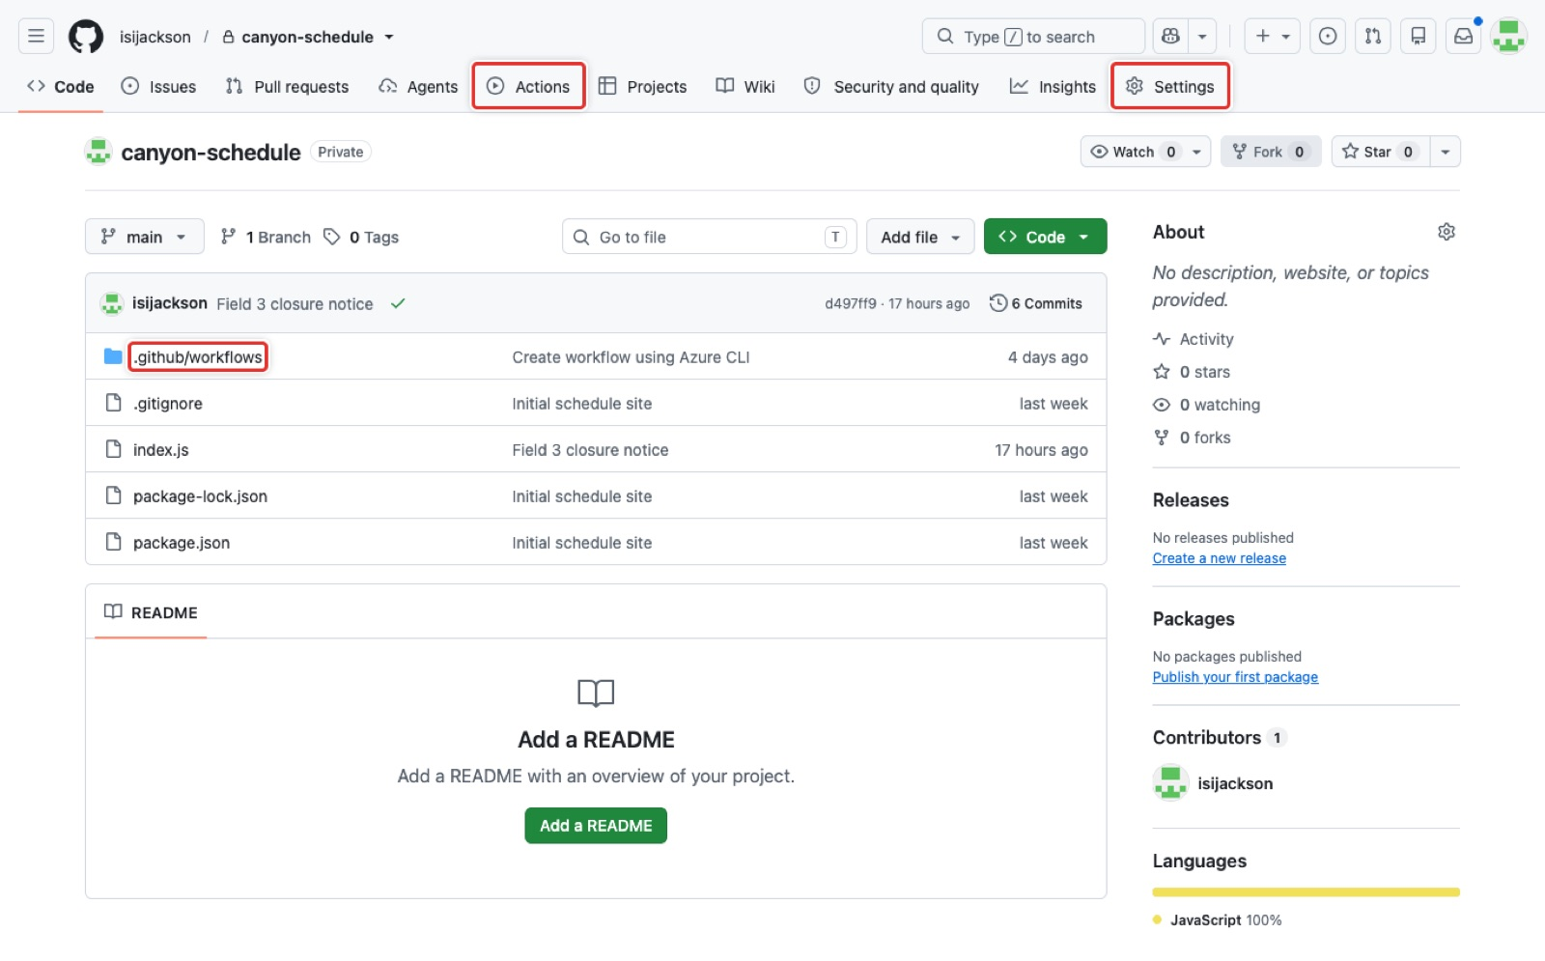
Figure 12. The repository on GitHub: the files, the Actions tab, the .github/workflows folder and Settings.

What GitHub's Quick setup commands mean
The Quick setup page of a new repository suggests commands for starting from a folder on your laptop instead of cloning. They do the same job as Step 2d in a different order, and you can use them instead of Step 2d (not as well as). For a repository named canyon-schedule the page shows:
Shown on GitHub's Quick setup page (…or create a new repository on the command line)
echo "# canyon-schedule" >> README.md
git init
git add README.md
git commit -m "first commit"
git branch -M main
git remote add origin https://github.com/<your user>/canyon-schedule.git
git push -u origin main

Line | What it does and what it prints
echo "# canyon-schedule" >> README.md | Creates a file README.md holding one heading line. (The # is inside quotes, so zsh keeps it; it is Markdown for a heading.)
git init | Turns the current folder into a Git repository by creating the hidden .git folder. Prints Initialized empty Git repository in .../.git/.
git add README.md | Marks README.md for the first commit.
git commit -m "first commit" | Saves the first snapshot on your laptop: [main (root-commit) ...] first commit, 1 file changed.
git branch -M main | Renames the current branch to main, in case Git started it under another name such as master.
git remote add origin https://github.com/... | Records the GitHub repository's address under the short name origin, so later commands can say origin instead of the full address.
git push -u origin main | Uploads main to GitHub. -u makes Git remember the pairing, so later a plain git push or git pull knows where to go; it prints branch 'main' set up to track 'origin/main'.

The same route with the lab's app instead of a README: make an empty folder, copy the files in, and commit them all at once.
Terminal on your laptop: the Quick setup route with the lab's files
mkdir -p ~/canyon-schedule
cd ~/canyon-schedule
cp -r "$LAB/canyon-schedule/." .
git init
git add .
git commit -m "Initial schedule site"
git branch -M main
git remote add origin "https://github.com/$GH_USER/canyon-schedule.git"
git push -u origin main

With the GitHub CLI the repository on GitHub does not even have to exist first. After git init, git add . and git commit in the folder, one command creates the public repository on GitHub, adds origin and pushes: gh repo create canyon-schedule --public --source=. --push. --source=. means "use this folder", --push means "upload the commits". This is what scripts/deploy-lab2.sh does. Use only one route: if the repository already exists on GitHub, gh repo create stops with an error that the name is taken.
Expected result
The repository page on GitHub lists .gitignore, index.js, package-lock.json and package.json, and the local page shows Canyon Youth Soccer — Fall Schedule (Validation 2). Checkpoint: a second teammate signs in (Step 2a), clones the repository, runs npm install and npm start, and sees the same page. Fix that before Part C.

Part C. Connect the pipeline (15 min)

Step 3. Deployment Center: GitHub, repository, branch, GitHub Actions
Console: where to click
Web App → Deployment Center → Settings tab (1). Source GitHub; authorise if asked; Organization your GitHub user, Repository canyon-schedule, Branch main; Build provider GitHub Actions; the Runtime stack and version are read from the app (2). Save.
Azure commits a workflow file under .github/workflows/ in the repository and stores a publish-profile secret. The first run starts at once; the Logs tab (1) lists every deployment afterwards.

What the next figure shows: The Settings tab (1) of the Deployment Center after the connection was made. The GitHub group (2) shows Source GitHub, Organization isijackson, Repository canyon-schedule, Branch main, Build provider GitHub Actions and the runtime Node 24-lts. Before you connect, the same fields are dropdowns and a Save button sits at the top; saving is what writes the workflow file into your repository.
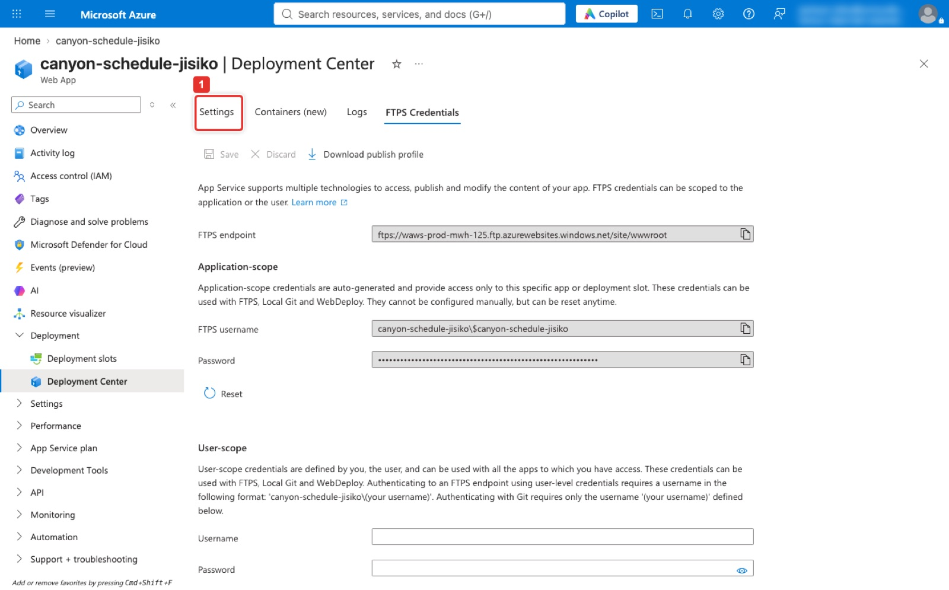
Figure 13. Deployment Center → Settings: Source GitHub, organization, repository, branch, build provider GitHub Actions.
What the next figure shows: The Logs tab of the Deployment Center. Each push produced two rows: a Build/Deploy row authored by the GitHub user and an App logs row marked Succeeded (Active) for the version now live. The newest rows are the Field 3 closure notice of Part D; below them is the Update workflow using Azure CLI commit that connected the pipeline. A failed deploy shows Failed here, which is faster than reading the Actions log.
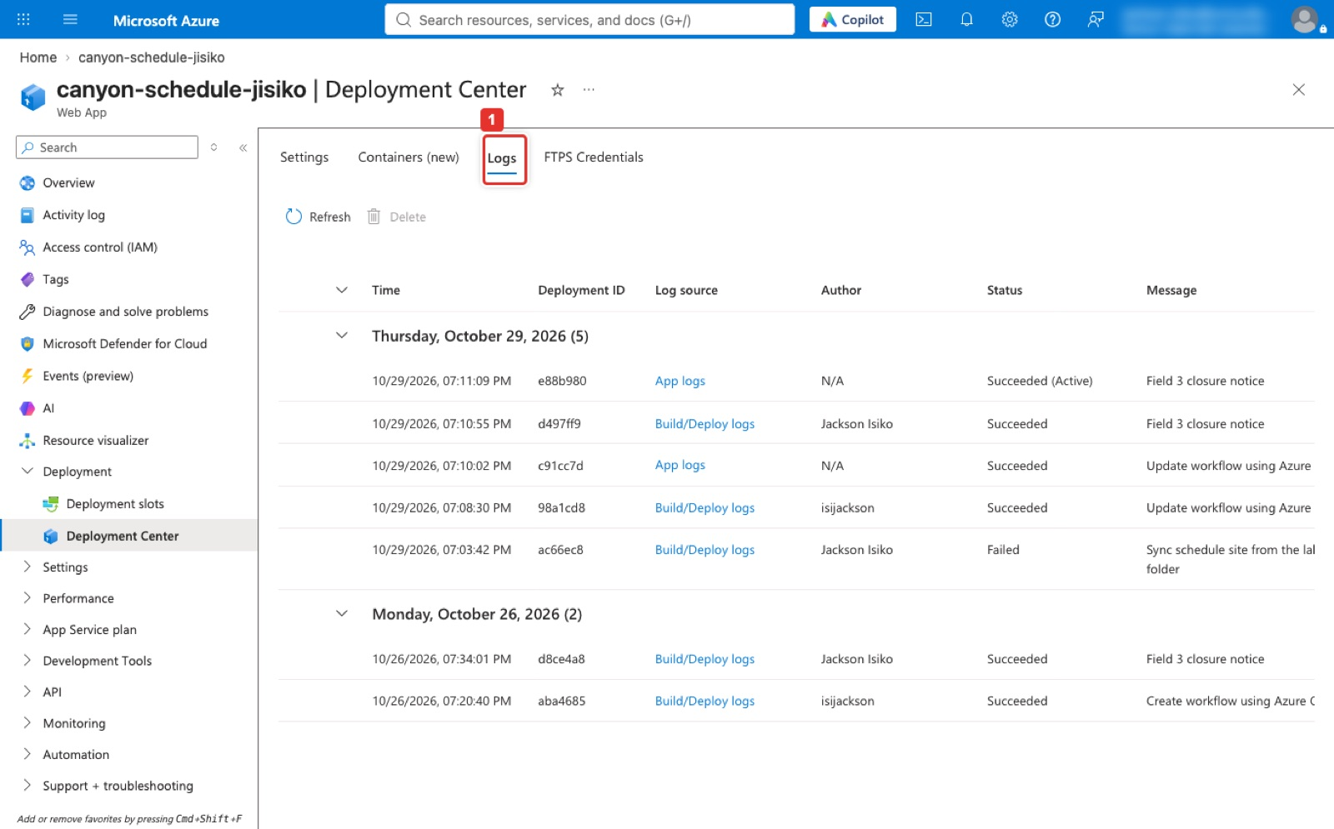
Figure 14. Deployment Center → Logs: every deployment with its commit message and status.
Terminal on your laptop (same result; the script passes the gh token so no second GitHub login is needed)
az webapp deployment github-actions add -g canyon-soccer-rg -n "$APP" --repo "$GH_USER/canyon-schedule" --branch main --login-with-github --force
RUN=$(gh run list -R "$GH_USER/canyon-schedule" --limit 1 --json databaseId --jq '.[0].databaseId')
gh run watch -R "$GH_USER/canyon-schedule" "$RUN" --exit-status && echo "first run green"
curl -s "https://$APP.azurewebsites.net" | grep -o '<h1>.*</h1>'

Line | What it does and what it prints
az webapp deployment github-actions add ... | Connects the Web App to the repository: Azure writes a workflow file into .github/workflows/, stores the publish-profile secret in the repository, and starts the first pipeline run. --login-with-github signs in through GitHub in the browser if needed; --force replaces an older workflow file. A trailing Not Found message from the CLI can be ignored.
RUN=$(gh run list ... --jq '.[0].databaseId') | Asks GitHub for the newest pipeline run and stores its number in RUN. Nothing is printed; echo $RUN shows it.
gh run watch ... "$RUN" --exit-status && echo "first run green" | Follows that run live, step by step, until it ends. --exit-status makes a failed run count as an error, so first run green is printed only after a success.
curl -s "https://$APP.azurewebsites.net" | grep -o '<h1>.*</h1>' | Downloads the live page and keeps only the heading: <h1>Canyon Youth Soccer — Fall Schedule</h1>. If nothing prints, wait a minute and run it again; the site restarts after a deploy.

What the next figure shows: Part 3 of the script. The Azure CLI writes the workflow and the secret and then reports a spurious Not Found, which the script ignores. gh run list shows the run Build and deploy Node.js app to Azure Web App in progress; gh run watch waits for it and prints first run green; the final curl is Validation 3: the live site now serves <h1>Canyon Youth Soccer — Fall Schedule</h1> instead of the Azure default page.
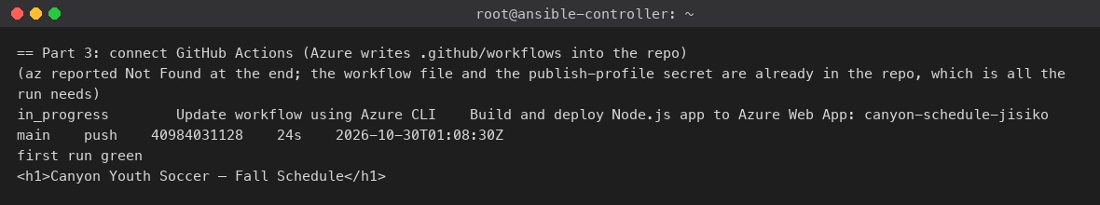
Figure 15. The scripted Part 3: the run goes green and the live site serves the heading.
What the next figure shows: The runs as the GitHub CLI shows them, newest first. The oldest run failed: its deploy step got Unauthorized 401 because the publish-profile secret in the repository belonged to a Web App that had been deleted earlier. Reconnecting with --force refreshed the secret and the next run, Update workflow using Azure CLI, went green, followed by the Field 3 closure notice run. gh run view shows the single job build-and-deploy, 27 seconds, and the link to the same run on GitHub's web page, which is where Screenshot 3 comes from.
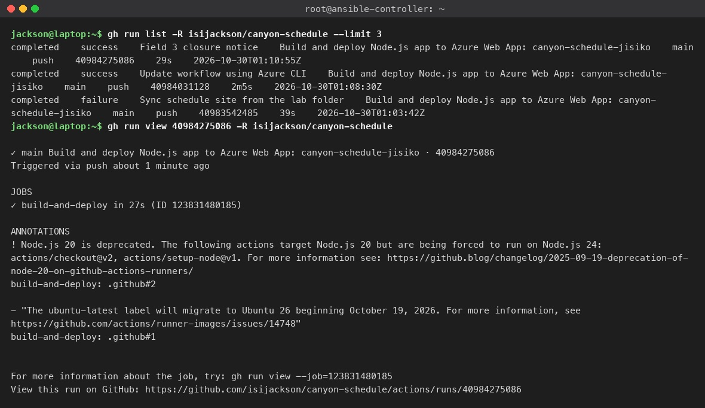
Figure 16. gh run list and gh run view: three runs, the failed first one, then two green.
What the next figure shows: The Actions tab. The sidebar (1) lists the one workflow, Build and deploy Node.js app to Azure Web App: canyon-schedule-jisiko, named from the name: line of the YAML file. Each row is one run with its commit message, number, commit, branch and duration; the newest (2) is the Field 3 closure notice, 29 s. The red row is the first run that failed with the stale publish-profile secret, the two green rows below it came after --force reconnected the pipeline. Click a run to open it.
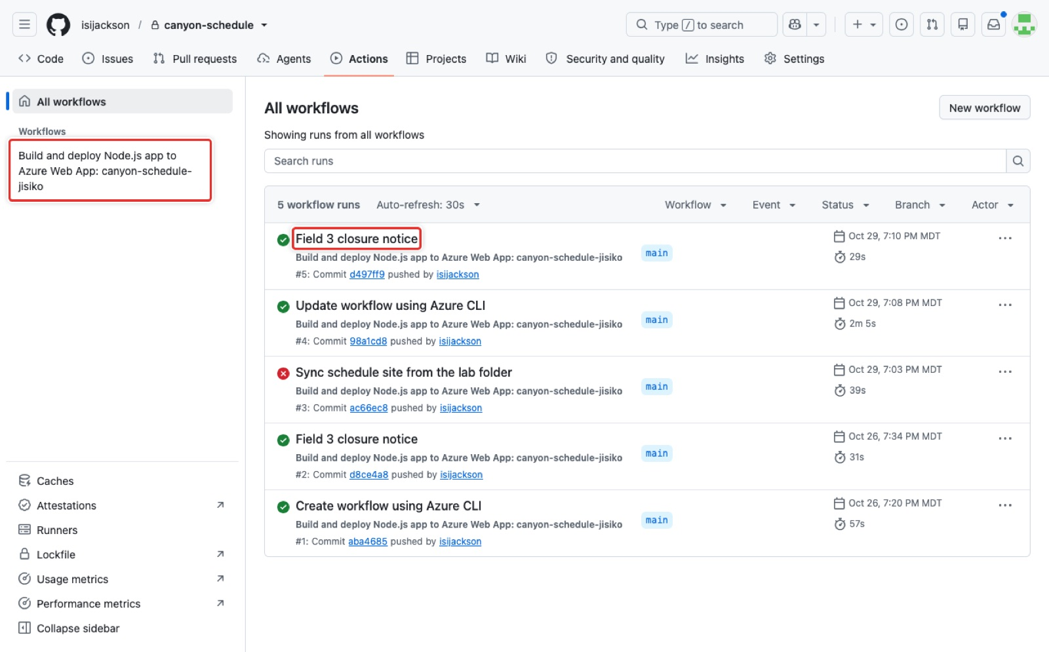
Figure 17. Actions: the workflow in the sidebar and the list of runs, newest first.
What the next figure shows: The run page for the Field 3 closure notice. Triggered via push by isijackson on main, Status Success, total duration 29 s. The single job (1) build-and-deploy is both the build and the deploy; click it to read every step's log, which is what the Canvas checkpoint asks you to do (which step builds, which step deploys). The Annotations block carries two warnings from GitHub about Node.js 20 actions and the ubuntu-latest label change, neither of which affects the result.
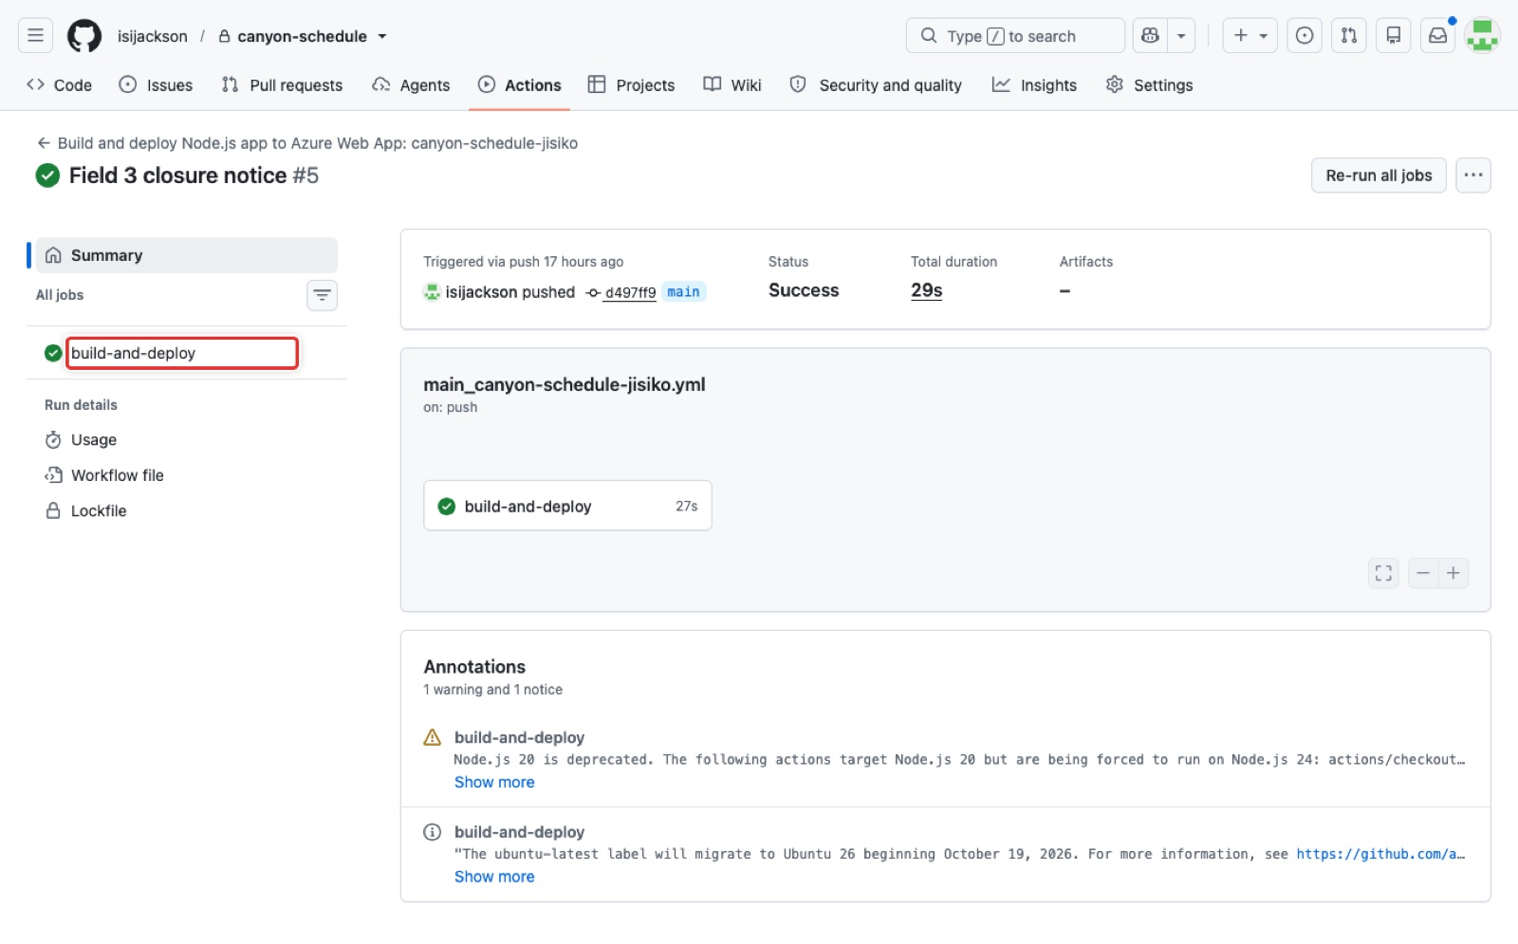
Figure 18. One run: the build-and-deploy job, its trigger, status and duration.
What the next figure shows: The job page that opens when you click build-and-deploy on a run. Every step is listed in order with its duration: Set up job, Run actions/checkout, Set up Node.js version, npm install, build, and test (1), which is the build step the Canvas checkpoint asks about, and Deploy to Azure Web App (2), which is the deploy step that uses the publish-profile secret; Post Run and Complete job close the job. Click any step to unfold its log; the deploy step's log ends with the Kudu deployment status and the live URL.
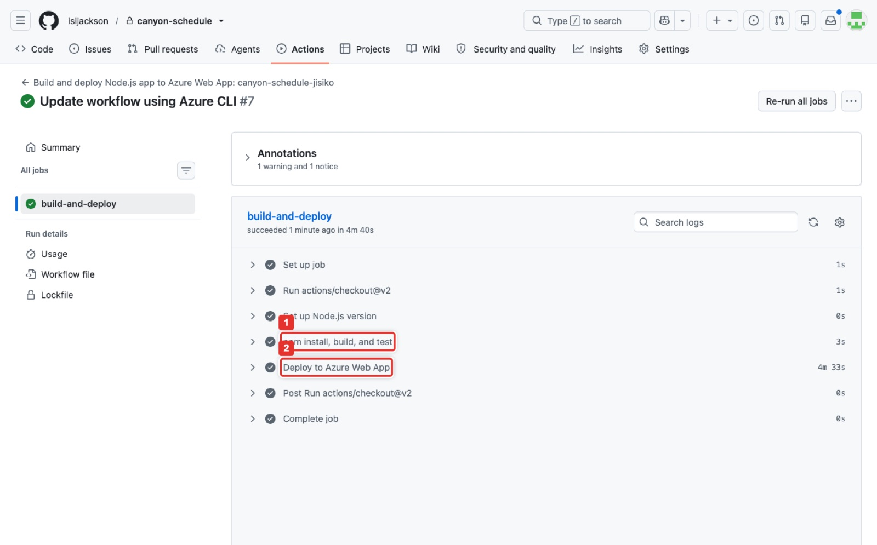
Figure 19. The job page: the steps of build-and-deploy, with the build step and the deploy step.
What the next figure shows: .github/workflows/main_canyon-schedule-jisiko.yml in the repository. Lines 6 to 10 are the trigger: on: push to branches: - main (1), plus workflow_dispatch for a manual run. The job build-and-deploy checks out the code, sets up Node 24, runs npm install, npm run build --if-present and npm test --if-present, then the Deploy to Azure Web App step uses azure/webapps-deploy@v2 with the app name, the production slot and publish-profile: ${{ secrets.AzureAppService_PublishProfile_... }} (2). The secret's value is never in the file.
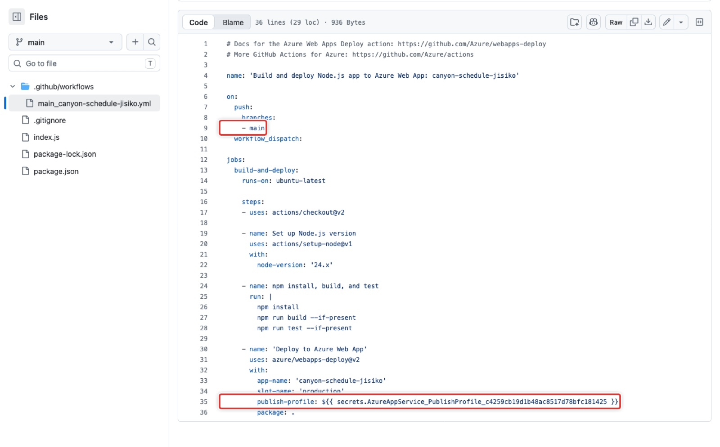
Figure 20. The workflow file Azure wrote: the trigger on main and the deploy step with the publish-profile secret.
What the next figure shows: The repository's Actions secrets page. One repository secret (1), AZUREAPPSERVICE_PUBLISHPROFILE_…, written by the Deployment Center when the pipeline was connected; GitHub shows its name and the update time, never its value. This is the secret the deploy step references. If the Web App is recreated, this value goes stale and the deploy job fails with 401: reconnect the pipeline (or run the script with --force) to refresh it. The keyless stretch in the README replaces it with OpenID Connect.
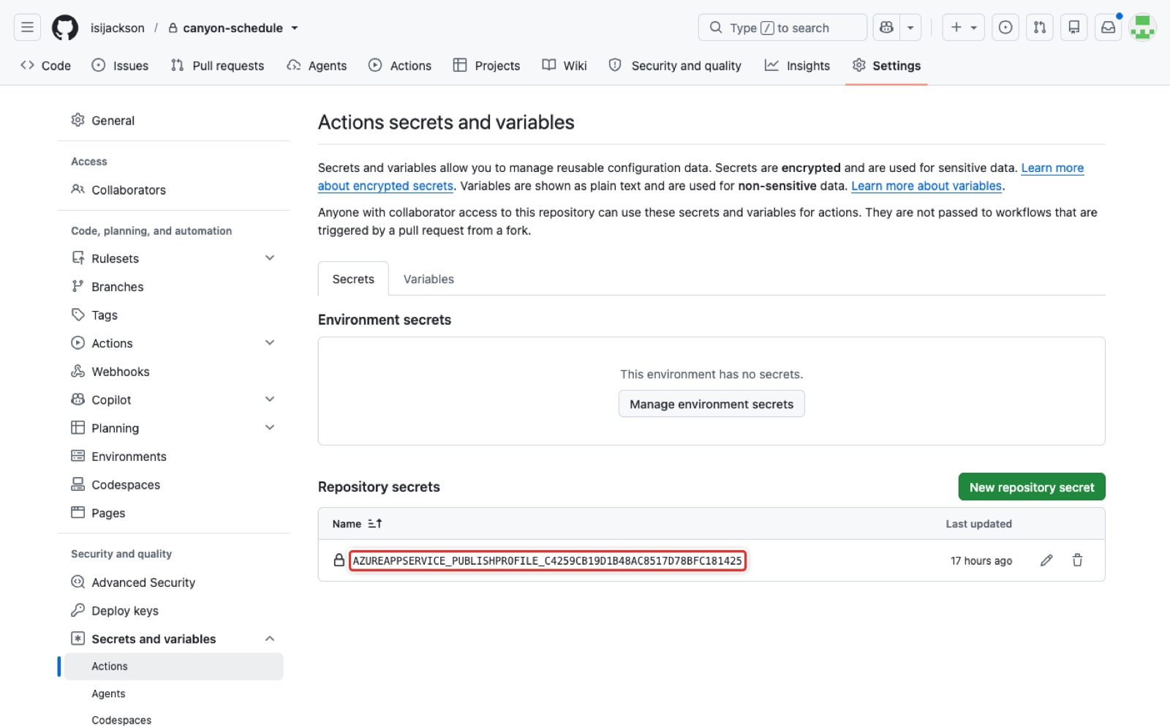
Figure 21. Settings → Secrets and variables → Actions: the publish-profile secret by name only.
Expected result
The run is green and the live URL shows the heading. Checkpoint: the build job runs npm install and npm run build --if-present; the deploy step is azure/webapps-deploy.

Part D. The live change drill (15 min)

Step 4. Push a change and time push-to-live
First pull, because Azure committed the workflow file to the repository:
Terminal on your laptop
git pull

Open index.js in an editor and add this paragraph under the existing schedule line, inside the HTML string: <p><strong>Field 3 closed for drainage repair on 14 Nov.</strong></p>. Save the file, then push and time it; date prints the clock time to start from.
Terminal on your laptop
git add .
git commit -m "Field 3 closure notice"
git push origin main
date
RUN=$(gh run list -R "$GH_USER/canyon-schedule" --limit 1 --json databaseId --jq '.[0].databaseId')
gh run watch -R "$GH_USER/canyon-schedule" "$RUN" --exit-status
curl -s "https://$APP.azurewebsites.net" | grep -o '<strong>.*</strong>'
date

Line | What it does and what it prints
git pull (the block above) | Downloads the workflow commit Azure added in Part C. Without it, the push below is refused with rejected, fetch first.
git add . and git commit -m "Field 3 closure notice" | Records the edited index.js as a new snapshot on your laptop: 1 file changed, 1 insertion(+) or similar.
git push origin main | Sends the commit to GitHub. The push itself is the trigger: the pipeline starts within seconds.
date | Prints the clock time, which starts your stopwatch.
RUN=... and gh run watch ... | As in Part C: find the newest run and follow it to the end.
curl ... | grep -o '<strong>.*</strong>' | Prints <strong>Field 3 closed for drainage repair on 14 Nov.</strong> once the new version is live. If it prints nothing, wait 30 seconds and run the line again.
date | The second clock time. The difference between the two is your push-to-live time for Canvas.

What the next figure shows: Part 4 of the script. It pulls the workflow commit, inserts the notice paragraph into index.js, commits, pushes and starts a stopwatch; it then watches the run and polls the site until the notice appears. push-to-live: 0 min 46 s is the answer to the checkpoint, and the last line is the <strong> paragraph as the live site serves it.
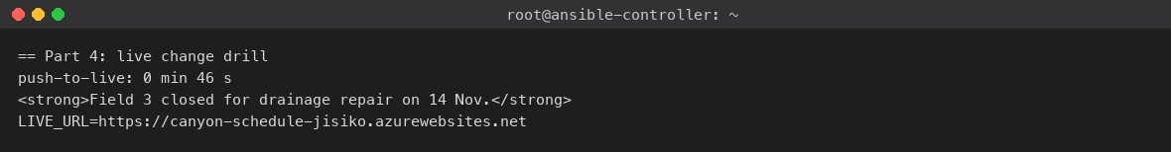
Figure 22. The scripted Part 4: push-to-live 0 min 46 s, and the notice served from the live site.
What the next figure shows: The live site in a browser after the drill. Under the heading and the Saturday schedule, the bold notice Field 3 closed for drainage repair on 14 Nov. is the paragraph that was pushed; the address above the capture is the Web App's default domain. This page, with the address bar, is Screenshot 4.
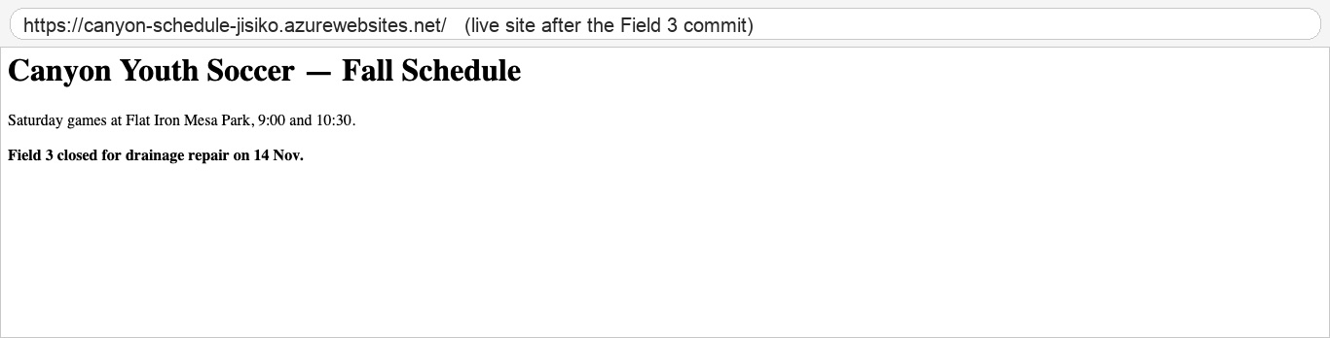
Figure 23. The live site after the push: the Field 3 notice under the schedule.
Expected result
The notice is live within a few minutes of the push (Validation 4): 46 seconds in the 2026-10-29 run, 1 min 24 s and 3 min 58 s in two runs on 2026-10-31, the difference being how long Azure's deploy step waits for the site to restart. Checkpoint: would the board accept four minutes on a Tuesday night? Yes; the old process took a week.

Part E. Verify the pipeline (10 min)
Run the commands in the same Terminal as Step 0, or set the four Step 0 variables again first.
Check | Command on the laptop | Expected
Web App exists and runs | az webapp show -g canyon-soccer-rg -n "$APP" --query "{state:state,host:defaultHostName,runtime:siteConfig.linuxFxVersion}" -o table | Running, the host, NODE|24-lts
Plan is Free F1 | az appservice plan show -g canyon-soccer-rg -n canyon-asp --query "{sku:sku.name,os:kind}" -o table | F1, linux
Workflow file is in the repo | gh api "repos/$GH_USER/canyon-schedule/contents/.github/workflows" --jq '.[].name' | main_canyon-schedule- plus your suffix, .yml
Secret exists, by name only | gh secret list -R "$GH_USER/canyon-schedule" | AZUREAPPSERVICE_PUBLISHPROFILE_...
Latest run is green | gh run list -R "$GH_USER/canyon-schedule" --limit 1 | completed success
Build and deploy steps | gh run view "$RUN" -R "$GH_USER/canyon-schedule" --log | grep -E 'npm install|webapps-deploy' | head (RUN is set in Step 4) | both lines present
Site serves the latest commit | curl -s "https://$APP.azurewebsites.net" | grep -o '<strong>.*</strong>' | the Field 3 notice
Deployment history on the Azure side | az webapp log deployment list -g canyon-soccer-rg -n "$APP" --query "[0].{status:status,active:active,message:message}" -o table | Status 4 (success), Active True, and a message whose commitMessage is Field 3 closure notice
App logs stream | az webapp log tail -g canyon-soccer-rg -n "$APP" | > node index.js then Schedule site running; Ctrl+C to stop

Note
Stretch: push a commit with a syntax error. The run fails at build, the live site keeps serving the previous version, and the Deployment Center Logs tab shows the failure. Fix and push: green again.

Part F. Clean up
Terminal on your laptop
az group delete -n canyon-soccer-rg --yes --no-wait

The plan and the app go with the group; F1 was free anyway. bash scripts/rollback-lab2.sh -y from the lab folder does the same, and --repo added to it also deletes the GitHub repository.
Expected result
Resource groups no longer lists canyon-soccer-rg. The repository can stay; it costs nothing.

Part G. What to submit (Canvas 2.2)
- The live URL.
- Screenshots 2 and 4 as before and after.
- The push-to-live minutes.
- The 2 to 3 sentence summary and the Team Collaboration and Documentation section.

Appendix. Quick troubleshooting
Symptom | Cause | Fix
Deploy step fails with Unauthorized (401) | Stale publish-profile secret (Web App recreated) | Reconnect Deployment Center, or az webapp deployment github-actions add ... --force
Live site shows the Azure default page after a green run | Workflow app-name does not match the Web App, or no start script | Fix the name; add "start": "node index.js"
Run fails on npm ci | No package-lock.json | npm install locally and commit the lock file
403 on Deployment Center | GitHub authorised with a different account than the repository owner | Re-authorise with the owner
az appservice plan create says quota | No F1 quota in that region for your subscription | Another region (the instructor used westus2), or B1
az prompts Replace existing workflow file? and dies in a script | The workflow already exists | Add --force
az login fails in the Vocareum sandbox | Conditional Access blocks the CLI app | Use the portal's Cloud Shell

Measured time on 2026-10-29: the scripted run took 8 minutes end to end, including a 2-minute first run and the 46-second live change. Rerun on 2026-10-31 for this edition: every verification command above was executed against the live app and its expected result column matches what came back; the live change took 3 min 58 s that time.

